**Task 3: Backup Configuration for Web Servers**

Marks will be given for configuring automated backups for Apache (/etc/httpd/, /var/www/html/) and Nginx (/etc/nginx/, /usr/share/nginx/html/), scheduling cron jobs to run every Tuesday at 12:00 AM, using the correct naming convention for backup files, and verifying backup integrity. Proper documentation and logs are necessary

To Check the log files

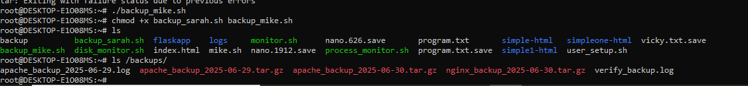

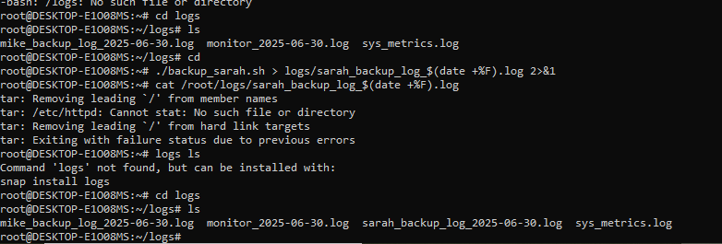

ls /backups/

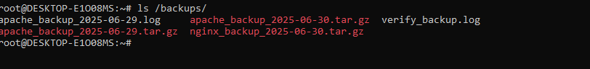

2. **View the backup contents**  
  
